// Adrian Pailler//
package Lesson7;
import java.util.*;
import javax.swing.*;
public class Searching_alg {
// array that will be created and used by all sorts/searches //
static ArrayList<String> arr = new ArrayList<String>() ;
// main method which will perform user required search/sort //
public static void main(String[] args) {
input(); // see input method (42-53) //
int ans = choice(); // decides which method to call. see choice method (29-40) //
if(ans==0) {
linear(); // see linear method (60-72) //
}
else if(ans==1) {
binary(); // see binary method (88-109) //
}
else if(ans==2){
bubble(); // see bubble method (74-86) //
}
else if(ans == 3){
selection(); // see selection method (111-125) //
}
else {
JOptionPane.showMessageDialog(null, "Bye!");
}
}
// 9/01/21 ; user decision //
public static int choice() {
JFrame choice = new JFrame();
String[] options = new String[4];
options[0] = new String("linear search");
options[1] = new String("binary search");
options[2] = new String("bubble sort");
options[3] = new String("selection sort");
// creates four options//
int ans =JOptionPane.showOptionDialog(choice.getContentPane(),"What would you like to do with your array?","Sorting and Searching",0,JOptionPane.INFORMATION_MESSAGE,null,options,null);
return ans;
// returns the value of ans to be used in the main method//
}
// 9/01/21 ; user input array //
public static ArrayList<String> input() {
// array that will be created and used by all sorts/searches //
String temp;
// Temporary value to add new elements //
int length = Integer.parseInt(JOptionPane.showInputDialog(null,"How long do you want your array?"));
// allows user to give predefined length //
for(int count = 0;length>count; count++) {
temp = JOptionPane.showInputDialog(null,"Input your array: ");
arr.add(temp);
}
return arr;
}
// 9//01//21 ; requests the search element //
public static String search() {
String element = JOptionPane.showInputDialog(null, "Which element are you looking for?");
return element;
}
// 9/01/21 ; Linear search //
public static void linear() {
String element = search(); // see search method (55-58) //
boolean flag = false;
for(int i = 0; i<arr.size();i++) {
if(arr.get(i).compareTo(element)==0) { // compares ascii values //
JOptionPane.showMessageDialog(null,"The index of your searched value is: "+arr.indexOf(element)); // if true, element found //
flag = true; // breaks loop//
}
}
if(flag == false) {
JOptionPane.showMessageDialog(null, "This value is not an element of the array");
}
}
// 10/01/21 ; bubble sort //
public static void bubble() {
String temp; // temporary value needed to change positions //
for(int i = 0;i<arr.size();i++) { // outer loop//
for(int a = 0; a<arr.size()-i-1;a++) { // inner loop //
if(arr.get(a).compareTo(arr.get(a+1))>0) { // compares both elements lexicographically //
temp = arr.get(a); //
arr.set(a,arr.get(a+1)); // swaps position
arr.set(a+1,temp); //
}
}
}
JOptionPane.showMessageDialog(null, "The sorted array is: "+arr);
}
// 11/01/21 ; binary search //
public static void binary() {
String element = search(); // see search method (55-58) //
bubble(); // array needs to be sorted first //
boolean flag = false;
int min = 0;
int max = arr.size()-1;
while(max>=min) {
int mid = (min+max)/2; // gets the midpoint
if((arr.get(mid).compareTo(element))<0) { // compares ascii //
min = mid+1;
} else if((arr.get(mid).compareTo(element))>0) {
max = mid-1;
} else {
JOptionPane.showMessageDialog(null, "Element found at index: "+mid);
min = arr.size()+1; // breaks while condition//
flag = true;
}
}
if(flag==false) { //if value is not an element //
JOptionPane.showMessageDialog(null, "This value is not an element of the array");
}
}
// 11/01/21 ; selection sort//
public static void selection() {
String temp;
int i,e; // will be counters to compare elements //
for(i=0;i<arr.size();i++) { // outer loop//
for(e=i+1; e<arr.size();e++) { // nested loop //
if(arr.get(i).compareTo(arr.get(e))>0) { // conditions to compare ascii //
temp = arr.get(i); //
arr.set(i, arr.get(e)); // swap values if condition is met
arr.set(e, temp); //
}
}
}
JOptionPane.showMessageDialog(null, "The sorted array is: "+arr);
}
}

Linear search:
Array: {g,4,6,c,e}
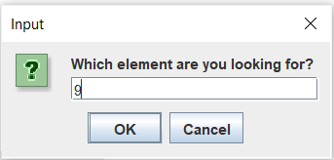
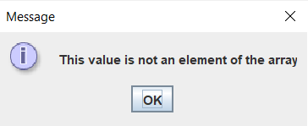
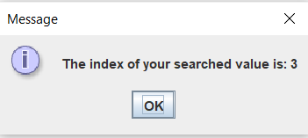
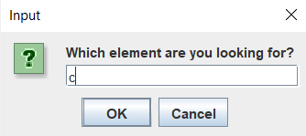
Search term:

Binary search:
Array: {g,4,6,c,e}
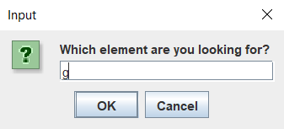
Search term:
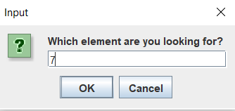

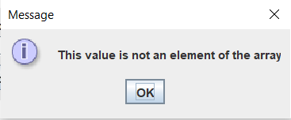
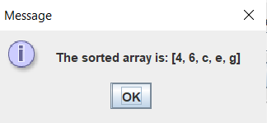
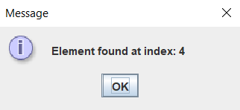
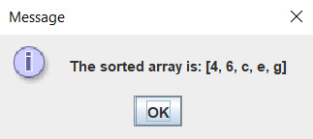
Sorted array:

Bubble sort:
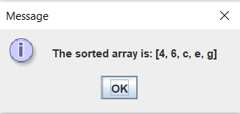
Array: {g,4,6,c,e}

Sequential sort:
Array: {g,4,6,c,e}

Array: {f,3,3,5,g,s,e,w,m,n}
